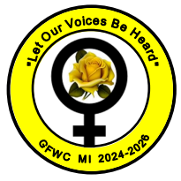
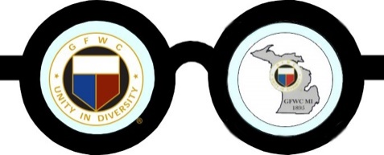

GFWC MI President’s E-Newsletter November 2025 Issue No. 16
From Rae Lynn Hicks, GFWC MI President

November 11, 2025
Veterans Day
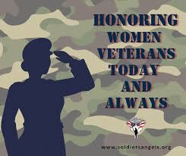

Please take time this Veterans Day and remember all those before us who believed in democracy and served our country. Especially those who gave their lives so that we could live with dignity and freedom for all.

Honoring one of our own. Meet Carol Habgood.
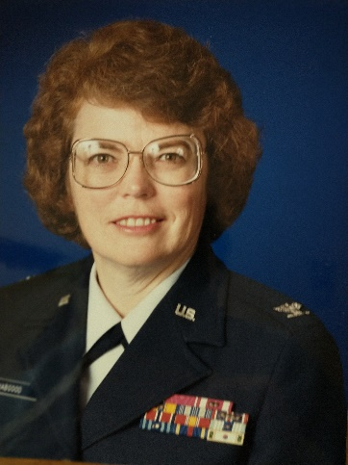
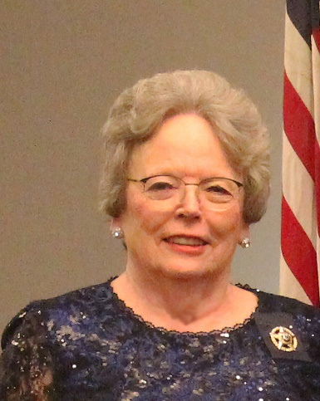
Serving in the United States Air Force,
November 1962 - June 1992.

“That was another lifetime. In 1962, when I graduated from college, I was looking for a job that would pay me the same as a man. Ha! What an eye-opener. Believe it or not, the military was the only place I could expect to get the same basic pay as my male counterpart. However, in 1962, there were legal restrictions on the number of women who could serve in the Air Force (only 2% of the active-duty force). There were restrictions on how many women could serve at each rank, and restrictions on marital status. You were not allowed to be married. Furthermore, if you married a widower with children, the woman was released from active duty, but the man could remain.
“When I enlisted in the Air Force, I was looking not only to serve my country, but to have a meaningful life experience. I had no idea of making it a career at that time. But it gets into your blood, and before I knew it, the Air Force became my life’s career.
“In 1967, President Lyndon Johnson signed into law a bill that removed many of the restrictions on women. For the first time, promotions for women had no restrictions.
“Along the way, I moved twelve times, an average of once every two and a half years. I lived in places I would never have dreamed of visiting on my own. I lived in Alaska two years after the devastating earthquake and one year before oil was discovered. I was in Japan for three years. And in between, I visited fourteen countries on Air Force business, going to many remote mountaintop communications sites.
“It was better than Mr. Toad’s wild ride in Disneyland. It was a unique lifetime experience I never expected in 1962.
“Serving as a woman in the military impacted my life and my involvement in GFWC. It changed my life, from small town girl to woman of the world, in all the best senses of the word. I not only traveled the world; I got valuable leadership experience. GFWC involvement is really just an extension of that military experience. What I learned in the Air Force has translated very well into GFWC club activity. The principles of leadership are the same.
“I retired from the Air Force in 1992 and was looking for something meaningful to occupy my time. That is how I found GFWC. I first joined the San Antonio Unit of the Women’s Overseas Service League (WOSL). The Women’s Overseas Service League is a national organization of women who served in and with the Armed Forces overseas. When I became unit president in 2000, I was advised that I would attend the meetings of the San Antonio Women’s Federation, as our WOSL unit had been a member of that city federation since the late 1920s. So, I attended every GFWC club meeting beginning in 2000, became active in club, district, and state federation activities, and in 2003 was invited to become an individual per capital member of GFWC. The rest is history. The more I became involved, the more I realized the value of GFWC.
I have served as GFWC Texas President (2018-2020).; National President of the Women’s Overseas Service League; and president of the Texas State Association of Parliamentarians.
“Being a GFWC clubwoman has been extremely rewarding. I currently serve as GFWC parliamentarian for the 2024-2026 administration, a truly rewarding experience that brings together all my club, district, and state federation knowledge. I know I will make friends wherever I go and will renew those friendships at GFWC annual conventions. I have watched those I have mentored blossom as they move up the ladder of leadership.
“Being a member of GFWC is being part of a special sisterhood with a common goal of improving the lives of everyone, and especially women and children.”
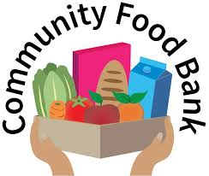

What is SNAP?
SNAP is a federal nutrition assistance program (formerly known as “food stamps”) that helps low-income individuals and families buy groceries. It is administered by the U.S. Department of Agriculture (USDA) through the Food and Nutrition Service (FNS) but managed at the state level.

How SNAP Works
- Participants receive benefits on an Electronic Benefit Transfer (EBT) card, similar to a debit card.
- The card can be used at authorized grocery stores, farmers markets, and online retailers (like Amazon and Walmart) to buy eligible food items

🍎 What You Can Buy with SNAP
Allowed:
- Fruits, vegetables, meat, fish, dairy
- Bread, cereals, snacks, non-alcoholic drinks
- Seeds and plants that produce food
Not Allowed:
- Alcohol, tobacco, vitamins, supplements
- Hot foods (prepared for immediate consumption)

- Non-food items (like soap or paper products)

Please contact your local food bank to see how you can donate either food or money to help those in need.

For pumpkin pie

